cldv poe part 2

ST10053561

Varsity College – Cape Town

CLDV6212

**Table of Contents**

QueueTrigger Codes 2

Console Application Codes 3

Figure 1 : Function Code 2

Figure 2 : Function Code – DB Controller Class 2

Figure 3 : Function Code - Getters and Setters Class 3

Figure 4 : Console Application Input Validation Part 1 3

Figure 5 : Console Application Input Validation Part 2 4

Figure 6 : Console Application Input Validation Part 3 4

Figure 7 : Console Application Input Validation Part 4 5

Figure 8 : Console Application Validation Checker - Valid Passport Code 6

Figure 9 : Console Application Validation Checker - Valid ID Code 7

Figure 10 : Console Application Validation Checker - Valid Serial number Code 8

Figure 11 : Console Application Validation Checker - Valid Bar Code 9

Figure 12 : Console Application Validation Checker - Valid data Handling Code 10

Figure 13 : Console Application Validation Checker - Valid Vaccination Centre Code 10

Figure 14 : Query Success Message1 11

Figure 15 : Query Success Message 2 11

Figure 16 : Query Success Message 3 11

Figure 17 : Query Success Message 4 11

Figure 18 : Query Success Message 5 11

Figure 19 : Data in Queue 12

Figure 20 : Azure SQL Database Data 12

Figure 21 : Azure SQL Database Data in Azure Portal 12

# QueueTrigger Codes

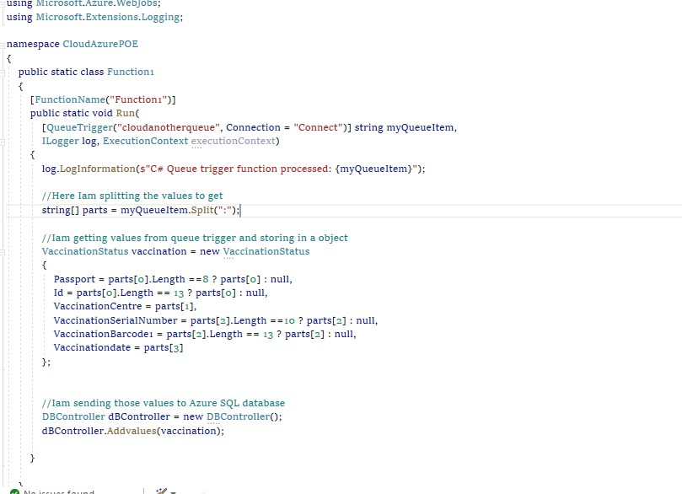

Figure : Function Code

Figure : Function Code – DB Controller Class

Figure : Function Code - Getters and Setters Class

# Console Application Codes

Figure : Console Application Input Validation Part 1

Figure : Console Application Input Validation Part 2

Figure : Console Application Input Validation Part 3

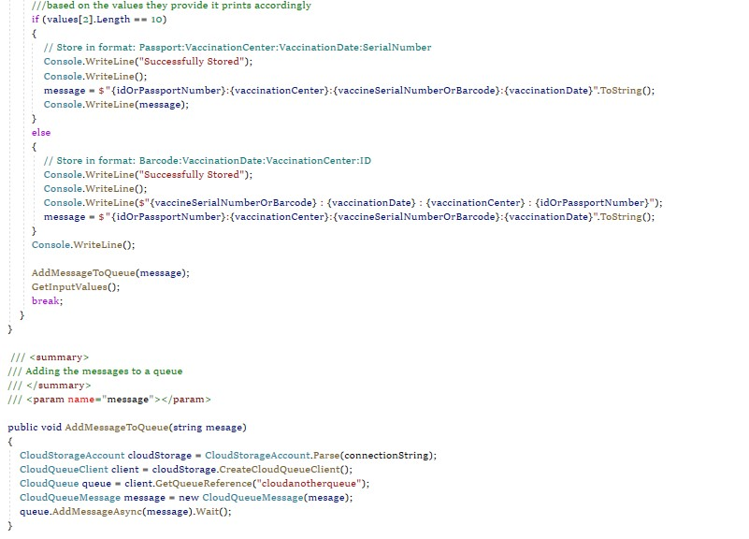

Figure : Console Application Input Validation Part 4

Figure : Console Application Validation Checker - Valid Passport Code

Figure : Console Application Validation Checker - Valid ID Code

Figure : Console Application Validation Checker - Valid Serial number Code

Figure : Console Application Validation Checker - Valid Bar Code

Figure : Console Application Validation Checker - Valid data Handling Code

Figure : Console Application Validation Checker - Valid Vaccination Centre Code

Figure 14 : Query Success Message1

Figure 15 : Query Success Message 2

Figure 16 : Query Success Message 3

Figure 17 : Query Success Message 4

Figure 18 : Query Success Message 5

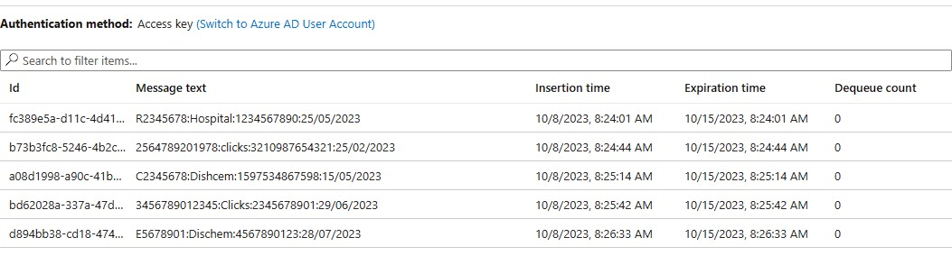

Figure : Data in Queue

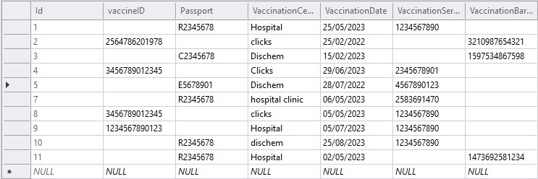

Figure : Azure SQL Database Data

Figure : Azure SQL Database Data in Azure Portal